Architecture Draft:

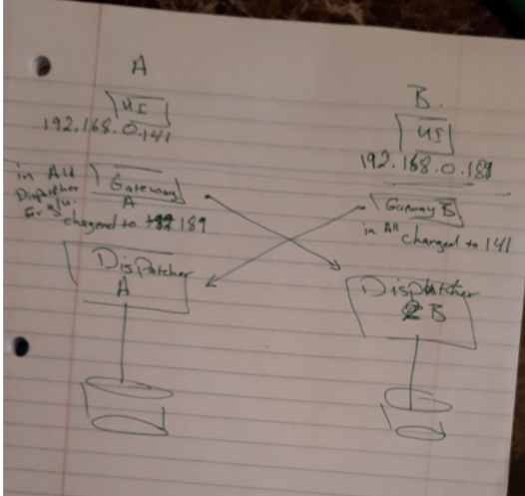

My IP address through the WIFI network

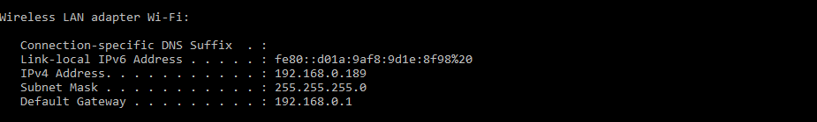

My NAT rule to access my VM guest since bridge mode is not working properly

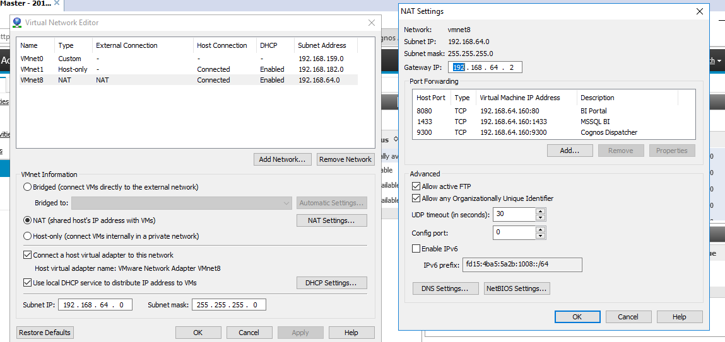

My VM network ip address

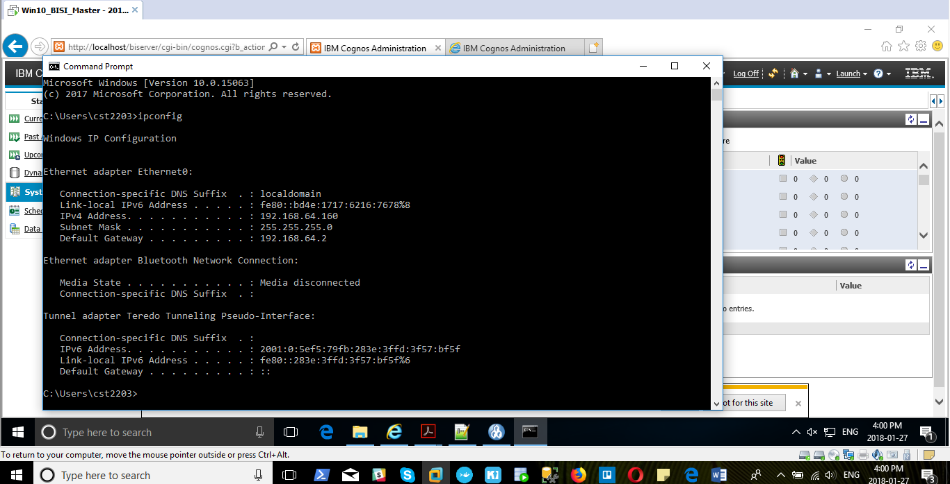

My gateway pointing to my partner dispatcher and Cognos services in Cognos Configuration:

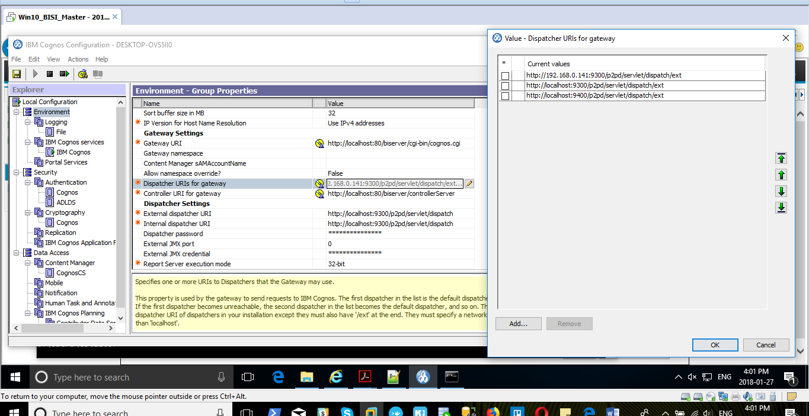

My dispatcher configuration:

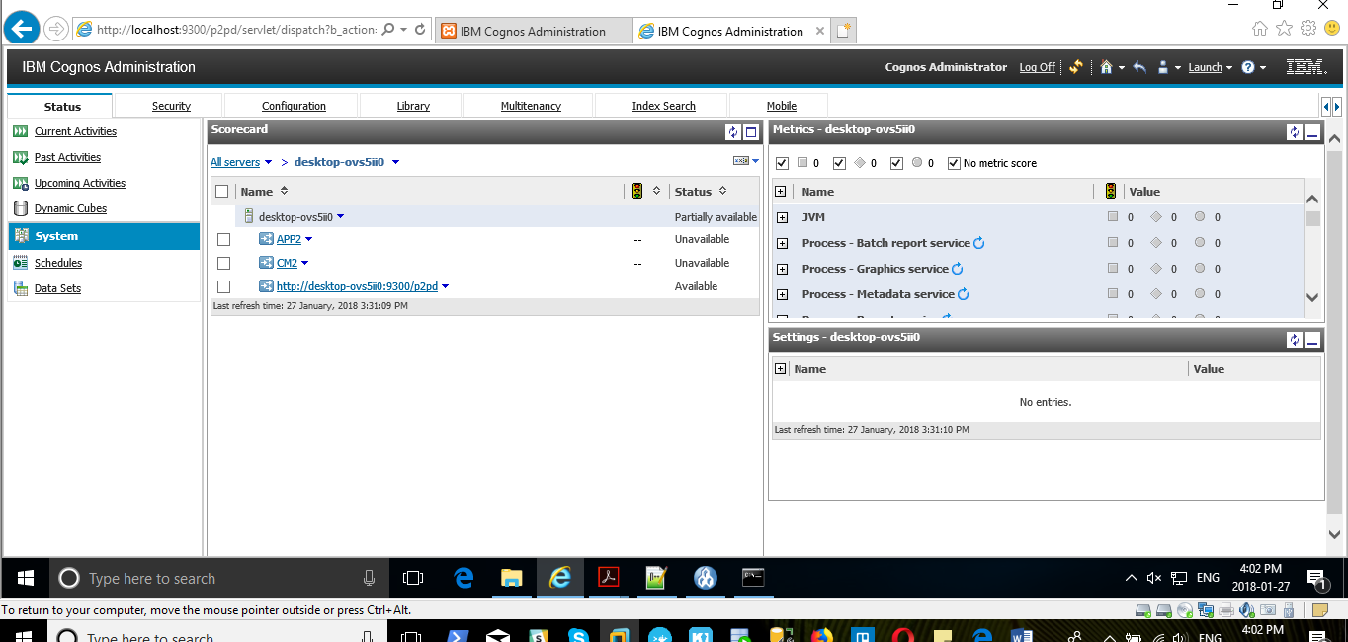

My partner IP address:

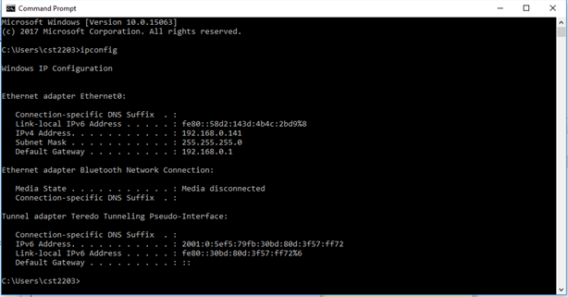

My partner gateway IP pointing to my dispatcher

